Selection: 1

| Please choose a lesson, or type 0 to return to course menu.

1: Introduction 2: Probability1

3: Probability2 4: ConditionalProbability

5: Expectations 6: Variance

7: CommonDistros 8: Asymptotics

9: T Confidence Intervals 10: Hypothesis Testing

11: P Values 12: Power

13: Multiple Testing 14: Resampling

Selection: 11

| Attempting to load lesson dependencies...

| Package ‘ggplot2’ loaded correctly!

| | | 0%

| P_Values. (Slides for this and other Data Science courses may be found at

| github https://github.com/DataScienceSpecialization/courses/. If you care to

| use them, they must be downloaded as a zip file and viewed locally. This

| lesson corresponds to 06_Statistical_Inference/10_pValues.)

...

| |== | 2%

| In this lesson, as the name suggests, we'll discuss p-values which have

| nothing to do with urological testing. Instead they are the most common

| measure of statistical significance.

...

| |=== | 5%

| However, because they're popular they're used a lot, and often they're

| misused or misinterpreted. In this lecture we'll focus on how to generate

| them and interpret them correctly.

...

| |===== | 7%

| The question motivating p-values is this. Given that we have some null

| hypothesis concerning our data (for example, its mean), how unusual or

| extreme is the sample value we get from our data? Is our test statistic

| consistent with our hypothesis? So there are, implicitly, three steps we have

| to take to answer these types of questions.

...

| |======= | 10%

| What do you think the first step is?

1: Calculate a test statistic from the data

2: Compare the test statistic to a Z or t quantile

3: Create a null hypothesis

4: Consult your crystal ball

Selection: 3

| You nailed it! Good job!

| |======== | 12%

| So we have to begin with a null hypothesis which is a reasoned guess at some

| distribution of a data summary (a statistic). Recall from the last lesson

| that the null hypothesis H_0 is a baseline against which we'll measure an

| alternative hypothesis using the actual observed data.

...

| |========== | 14%

| So you propose a null hypothesis. What's the next step?

1: Calculate a test statistic from the given data

2: Compare the test statistic to a Z or t score

3: Reject H_0

4: Go back to the crystal ball

Selection: 1

| That's the answer I was looking for.

| |============ | 17%

| Now you have a proposed statistic (from your reasoned hypothesis) and a test

| statistic computed from your gathered data. What's the final step?

1: Go back to the crystal ball

2: Calculate a test statistic from the given data

3: Compare the test statistic to the hypothetical distribution

4: Reject H_0

Selection: 3

| Excellent job!

| |============= | 19%

| Your comparison tells you how "extreme" the test value is toward the

| alternative hypothesis. The p-value is the probability under the null

| hypothesis of obtaining evidence as or more extreme than your test statistic

| (obtained from your observed data) in the direction of the alternative

| hypothesis.

...

| |=============== | 21%

| So if the p-value (probability of seeing your test statistic) is small, then

| one of two things happens. EITHER H_0 is true and you have observed a rare

| event (in this unusual test statistic) OR H_0 is false. Let's go through an

| example.

...

| |================= | 24%

| Suppose that you get a t statistic of 2.5 with 15 df testing H_0, (that mu =

| mu_0) versus an alternative H_a (that mu > mu_0). We want to find the

| probability of getting a t statistic as large as 2.5.

...

| |================== | 26%

| R can help us! We can use the R function pt, the distribution function of the

| t distribution. This function returns one of two probabilities, EITHER the

| probability of X > q (if lower.tail is FALSE) OR X <= q (if lower.tail is

| TRUE), where q is a quantile argument. Here we'll set q=2.5, df=15,

| lower.tail=FALSE since H_a says that mu>mu_0. We have to gauge the extremity

| in the direction of H_a. Run this now.

> pt(2.5, 15, lower.tail=FALSE)

[1] 0.0122529

| Nice work!

| |==================== | 29%

| This result tells us that, if H_0 were true, we would see this large a test

| statistic with probability 1% which is rather a small probability.

...

| |====================== | 31%

| What should we do?

1: Consult the crystal ball

2: Fail to reject H_0

3: Reject H_0

Selection: 3

| Keep up the great work!

| |======================= | 33%

| Another way to think about a p-value is as an attained significance level.

| This is a fancy way of saying that the p-value is the smallest value of alpha

| at which you will reject the null hypothesis.

...

| |========================= | 36%

| Recall the example from our last lesson in which we computed a test statistic

| of 2. Our H_0 said that mu_0 = 30 and the alternative H_a that mu > 30.

| Assume we used a Z test (normal distribution). We rejected the one sided test

| when alpha was set to 0.05.

...

| |=========================== | 38%

| Why did we reject? Find the quantile associated with this test, that's the

| place to start. Use qnorm at the 95th percentile.

> qnorm(.95)

[1] 1.644854

| You're the best!

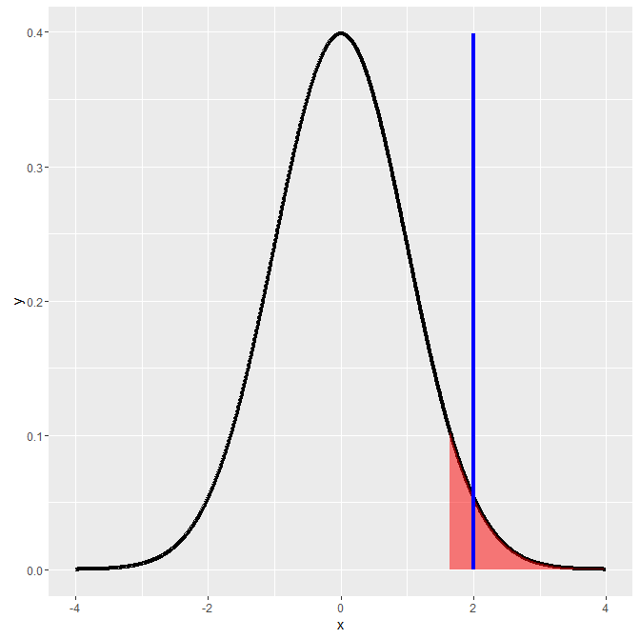

| |============================ | 40%

| We rejected H_0 because our data (the test statistic actually) favored H_a.

| The test statistic 2 (shown by the vertical blue line) falls in the shaded

| portion of this figure because it exceeds the quantile. As you know, the

| shaded portion represents 5% of the area under the curve.

...

| |============================== | 43%

| Now try the 99th percentile to see if we would still reject H_0.

> qnorm(.99)

[1] 2.326348

| You nailed it! Good job!

| |================================ | 45%

| Would we reject H_0 if alpha were .01?

1: Yes

2: No

Selection: 2

| You're the best!

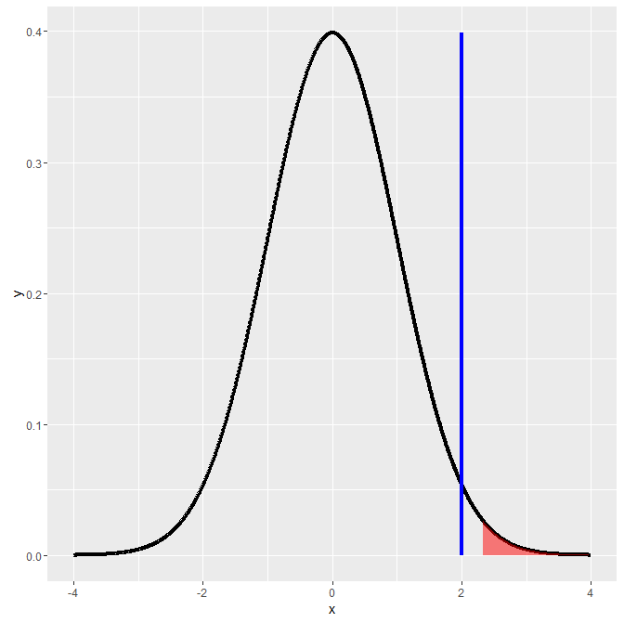

| |================================= | 48%

| Again, a picture's worth a thousand words, right? The vertical line at the

| test statistic 2 is not in the region of rejection.

...

| |=================================== | 50%

| So our data (the test statistic) tells us what the attained significance

| level is. We use the R function pnorm to give us this number. With the

| default values, specifically lower.tail=TRUE, this gives us the probability

| that a random draw from the distribution is less than or equal to the

| argument. Try it now with the test statistic value 2. Use the default values

| for all the other arguments.

> pnorm(2)

[1] 0.9772499

| That's a job well done!

| |===================================== | 52%

| Just as we thought, somewhere between .95 (where we rejected) and .99 (where

| we failed to reject). That's reassuring.

...

| |====================================== | 55%

| Now let's find the p value associated with this example. As before, we'll use

| pnorm. But this time we'll set the lower.tail argument to FALSE. This gives

| us the probability of X exceeding the test statistic, that is, the area under

| the curve to the right of test statistic. Try it now with the test statistic

| value 2.

> pnorm(2, lower.tail=FALSE)

[1] 0.02275013

| Keep up the great work!

| |======================================== | 57%

| This tells us that the attained level of significance is about 2%.

...

| |========================================== | 60%

| By reporting a p-value, instead of an alpha level and whether or not you

| reject H_0, reviewers of your work can hypothesis test at any alpha level

| they choose. The general rule is that if the p-value is less than the

| specified alpha you reject the null hypothesis and if it's greater you fail

| to reject.

...

| |=========================================== | 62%

| For a two sided hypothesis test, you have to double the smaller of the two

| one-sided p values. We'll see an example of this shortly. Most software

| assumes a two-sided test and automatically doubles the p value.

...

| |============================================= | 64%

| Now for the two-sided test. Recall the binomial example from the last lesson

| - the family with 8 children, 7 of whom are girls. You want to test H_0, that

| p=.5, where p is the probability of a girl (like a fair coin flip). H_a is

| that p is not equal to .5. It's either greater or less than .5.

...

| |=============================================== | 67%

| This is a two-sided test. First we find the probability of having at least i

| girls, for i running from 0 to 8. We have a vector of these probabilities,

| mybin. Look at it now.

> mybin

[1] 1.00000000 0.99609375 0.96484375 0.85546875 0.63671875 0.36328125 0.14453125

[8] 0.03515625 0.00390625

| That's the answer I was looking for.

| |================================================ | 69%

| The second last value shows us that the probability of having at least 7

| girls (out of 8 children) is .035, assuming that genders are equally likely

| (p=.5). You can verify this with the R function pbinom, with the arguments

| 6, size=8, prob=.5, and lower.tail=FALSE. (This last yields the probability

| that X>6.) Try this now.

> pbinom(6, size=8, prob=.5,lower.tail=FALSE)

[1] 0.03515625

| Keep working like that and you'll get there!

| |================================================== | 71%

| We see a probability of about .03. Should we reject or fail to reject H_0 if

| alpha = .05?

1: Reject

2: Fail to reject

Selection: 1

| All that hard work is paying off!

| |==================================================== | 74%

| We see a probability of about .03. Should we reject or fail to reject H_0 if

| alpha = .04?

1: Reject

2: Fail to reject

Selection: 1

| You nailed it! Good job!

| |===================================================== | 76%

| We see a probability of about .03. Should we reject or fail to reject H_0 if

| alpha = .03?

1: Fail to reject

2: Reject

Selection: 1

| You nailed it! Good job!

| |======================================================= | 79%

| For the other side of the test we want the probability that X<=7, again out

| of a sample of size 8 with probability .5. Again, we use pbinom, this time

| with an argument of 7 and lower.tail=TRUE. Try this now.

> pbinom(7, size=8, prob=.5,lower.tail=TRUE)

[1] 0.9960938

| Nice work!

| |========================================================= | 81%

| So it's pretty likely (probability .996) that out of 8 children you'll have

| at most 7 girls. The p value of this two sided test is 2*the smaller of the

| two one-sided values. In this case the lower value is .035, so 2*.035 is the

| p-value for this two-sided test.

...

| |========================================================== | 83%

| Now a final example using a Poisson distribution. Remember that this is

| discrete and it involves counts or rates of counts. The example from the

| slides involves rates of infections in a hospital.

...

| |============================================================ | 86%

| Suppose that the hospital has an infection rate of 10 infections per 100

| person/days at risk. This is a rate of 0.1. Assume that an infection rate of

| 0.05 is the benchmark. This is our alpha level, recognize it? With this

| model, could the observed rate (.1) be larger than the benchmark 0.05 by

| chance or does it indicate a problem?

...

| |============================================================== | 88%

| In other words, H_0 says that lambda = 0.05 so lambda_0 * 100 = 5, and H_a

| says that lambda > 0.05. Is H_0 true and our observed rate (.1) is just a

| fluke OR should we reject H_0 ?

...

| |=============================================================== | 90%

| As before, R has the handy function ppois, which returns probabilities for

| Poisson distributions. We want the probability of seeing at least 9

| infections using a lambda value of 5 and lower.tail=FALSE. As when we used

| pbinom we have to use 9 as the argument since we're looking for a probability

| of a value greater than the argument. Try this now.

> ppois(9, 5, lower.tail=FALSE)

[1] 0.03182806

| That's a job well done!

| |================================================================= | 93%

| We see a probability of about .03. Should we reject or fail to reject H_0?

| (Remember those helpful pictures with shaded areas. Smaller areas mean

| smaller probabilities and vice versa.)

1: Reject

2: Fail to reject

Selection: 1

| You are amazing!

| |=================================================================== | 95%

| So we reject the infection rate hypothesized by H_0 since the data favors

| H_a, indicating that the rate is much higher.

...

| |==================================================================== | 98%

| Congrats! You finished this lesson. We hope you p-valued it.

...

| |======================================================================| 100%

| Would you like to receive credit for completing this course on Coursera.org?

1: No

2: Yes

Selection: 2

What is your email address? sweeyean@gmail.com

What is your assignment token? BAA5Pm8MsEmnPKtK

Grade submission succeeded!

| That's the answer I was looking for.

| You've reached the end of this lesson! Returning to the main menu...

| Please choose a course, or type 0 to exit swirl.

1: Statistical Inference

2: Take me to the swirl course repository!

Selection: